
Brine Tank Assemble Steps:

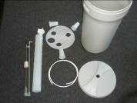 | 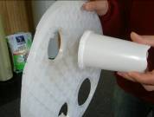 | 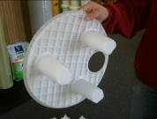
1.  All Parts: Brine Tank, Tank Cover, Salt Grid, 3 Legs, Float Assemblage, Float Tube Assemblage, Brine Hose. | 2.  Snap legs into base. | 3.  Three legs with base.
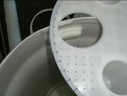 | 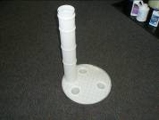 | 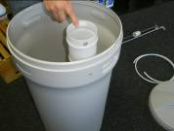
4.  Bend tabs on base away from legs to allow easier installation. | 5.  Insert float tube into base with hole for tubing facing outward. | 6.  Install base & float tube into tank aligning the hole in the float tube with the hole in the tank.
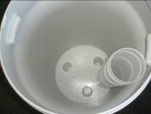 | 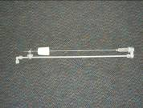  Too High | 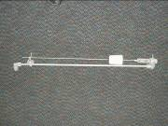  6” to 8” from Bottom
7.  Put the salt grid and float tube into brine tank. | 8.  Float can be set at the level desired.  Just slide rubber using to desired height. | 9.  Float can be set at the level desired.  Most system is 6” to 8” from bottom.

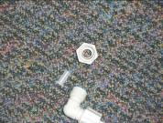 | 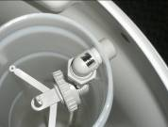 | 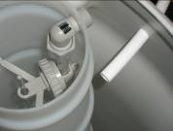
10.  Remove the nut & sleeve from top of float assemblage. | 11.  Put float assemblage into float tube. | 12.  Insert hose through hole into brine tank.
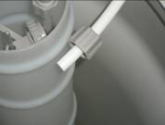 | 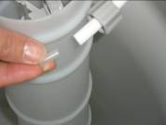 | 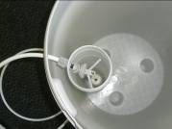
13.  Slide nut onto hose. | 14.  Insert support sleeve into hose. | 15.  Insert hose into elbow fitting.  Thread nut onto elbow hand tighten only.  Verify all is aligned as shown.
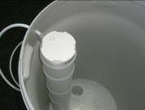 | 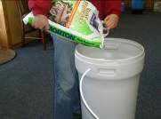 | 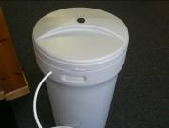
16.  Install cover on float tube. | 17.  Add salt into brine tank.  2 bags Max. | 18.  Install cover on brine tank.

The balance of the function is controlled by control valve.

